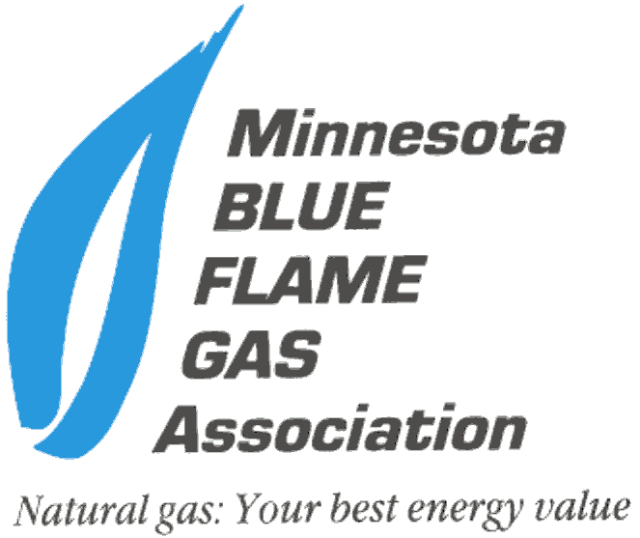
2016 Member Recruitment Program Details
1/21/16

Program Timeframe: January 1 – May 31, 2016

Purpose: Enhance the impact of the Association through increased membership. Gives current members the opportunity to invite peers, associates, etc., to join the Minnesota Blue Flame.

Incentive: Members can earn a $50 gift certificate for every new approved and paid member they recruit.
(A variety of gift cards will be available – Cabelas, Target, Home Depot, Best Buy, restaurant, etc.)

Pay Dates: Incentives will be paid March 31st & May 31st.

Dues Rates:
Associate Member & Contractor Member dues are $200/year. (Prorated for whatever month they join.)
Gas Marketers & Utility Dues – check with Diane for rates. dswintek@blueflame.org or call the
office at (763-424-1841)

New Member Criteria: The new member being recruited must fit the membership criteria outlined in the bylaws. They must be directly or indirectly involved in the natural gas industry in Minnesota. (See bylaw criteria listed below)

Recruitment Tools Available:
*Membership Application – on website and pdf attached to the recruitment program email.
*Blue Flame Membership Benefits Handout – on website & pdf attached to the recruitment program email.
*Website – Go to “Membership” tab on toolbar, click “Join Blue Flame” from the dropdown menu.
Prospective members can view our website to learn more about the Association and see
past events, newsletters, the membership directory, etc.

Bylaw Membership Criteria:
All applications for membership shall be in writing and subject to the approval of the Board of Directors. Assessed dues must be paid within 30 days of acceptance of your application to confirm your membership.
The memberships include:
(A) natural gas and liquefied natural gas distribution companies, municipal gas
distributors, gas producers, gas marketing distributors and gas transmission pipeline companies.
(B) trade allies such as individuals, manufacturers, dealers, distributors, suppliers or specifiers of
natural gas burning equipment and products.
(C) end users of natural gas
(D) other organizations with an interest in promoting the safe and efficient
use of natural gas by the residential, commercial and industrial markets.

